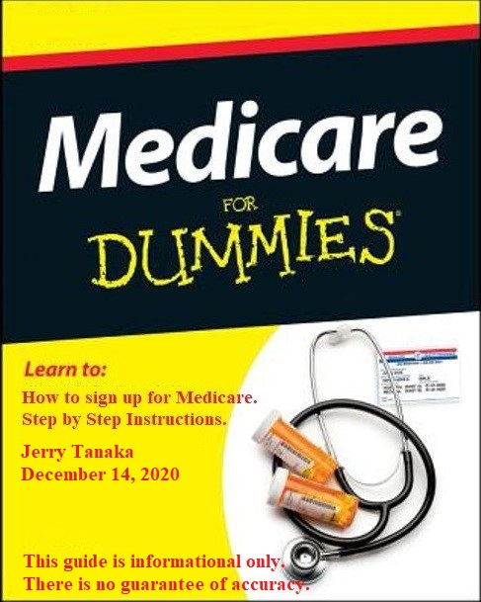
Medicare Coverage
When you're first eligible for Medicare, you have a 7-month Initial Enrollment Period to sign up for Part-A and/or Part-B.
If you're eligible for Medicare when you turn 65, you can sign up during the 7-month period that:
- Begins 3 months before the month you turn 65
- Includes the month you turn 65
- Ends 3 months after the month you turn 65

Medicare Part-A: Hospital Coverage (free for most people).
Part-A covers inpatient hospital stays and some health care.

You can apply for Part-A at age 65 without receiving Social Security
benefits by following the instructions below. If you are already receiving
Social Security benefits, then you already have Part-A (automatic).

Medicare Part-B: Medical Coverage (monthly fee).
Go to web site for Part-B costs (for 2021, standard fee is $144.50/month)
https://www.medicare.gov/your-medicare-costs/part-b-costs

Part-B covers doctor’s services, outpatient care, medical supplies and
preventive services.

NOTE: Medicare Part-A and Part-B are under Social Security Administration.

Part-C (Medicare Advantage Plan), Medigap, Part-D, E, F etc are under
private insurance companies (i.e., Aetna, Cigna, AARP, Blue Cross, etc). It
is referred as “supplemental medical insurance”.

Supplemental Medical Insurance

After you have applied for Medicare coverage Part-A and Part-B, you can choose one of the following Option-1 or Option-2 to cover both your health and prescription drug costs.

Option-1: Medicare Advantage Plan (Part-C):
Medicare Advantage plans provide your benefits instead of “Original” Medicare, and most include drug coverage (Part-D). Monthly premiums are generally lower but you may pay more out-of-pocket costs. These plans have networks, so you'll want to check if your preferred doctors are in network.

Some things to consider with this option:
Generally lower premiums
Generally higher out-of-pocket costs
Fewer premiums; medical and drug coverage combined in one plan
Plans have networks, check if preferred doctors are in network

Option-2: Medigap Plan (Medicare Supplemental) and Prescription Drug Plan
Medigap plans help pay for out-of-pocket costs, such as copays and deductibles. These plans do not cover drugs. Monthly premiums are generally higher, but most out-of-pocket medical costs are covered. You may see any doctor that accepts Medicare.

Prescription Drug Plan (also known as Part-D)
Help pay for out-of-pocket prescription drug costs usually not covered by Original Medicare.

Some things to consider with this option Medigap plans:
Generally higher monthly premiums
Generally low to no out-of-pocket costs
Do not cover prescription drugs (Part-D)
No networks, see any doctor that accepts Medicare

Prescription Drug Plans (Part-D):
Help pay for out-of-pocket prescription drug costs not covered by Original Medicare.

For further information:
Go to the web link below to get more information on the difference between Medicare Advantage Plan and Medigap.

https://www.investopedia.com/articles/personal-finance/071014/medigap-vs-medicare-advantage-which-better.asp

Instructions on how to apply for Medicare Part-A and B without SSA benefits

(1) Create a Social Security Account (optional, but will make life easier):
https://www.ssa.gov/myaccount/

(2) Apply for Medicare:
https://www.ssa.gov/benefits/medicare/

Open the web site, scroll down until you see “Apply for Medicare Only” and click on the blue button.

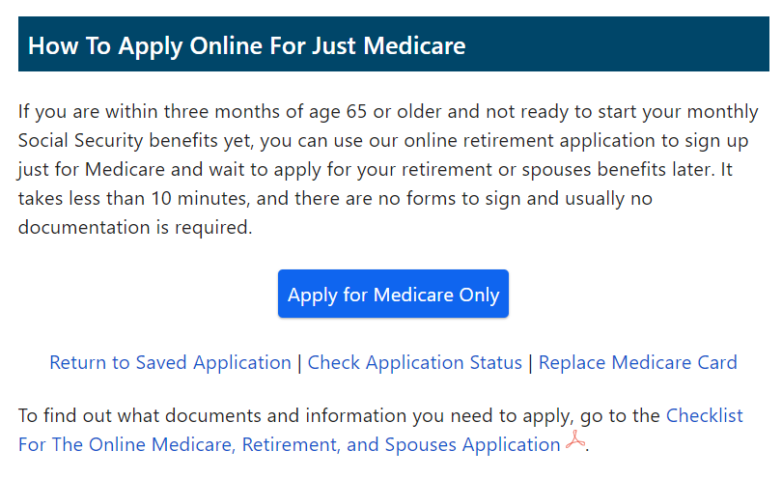

A series of panels (see pages 1-4) will ask you various questions. If you have created a Social Security Account (see Step #1), then many of the items will already be filled out.

(A) Select “Yes” when “Enroll Part-B” is asked. Otherwise, you may pay a penalty later.

(B) You will receive a “Re-Entry” or “Confirmation Number”, see 4.
In the example that number is “12345678” … Please keep for future reference.
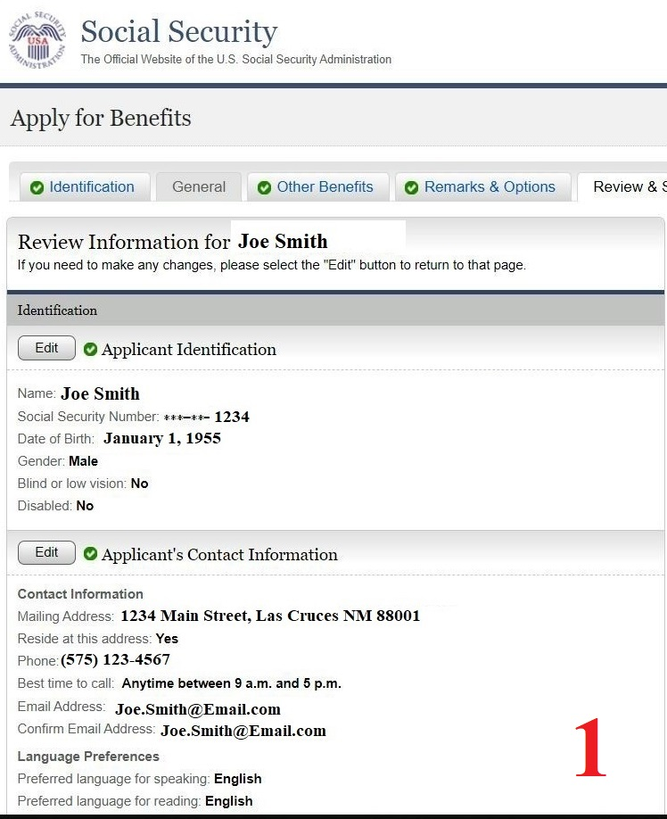

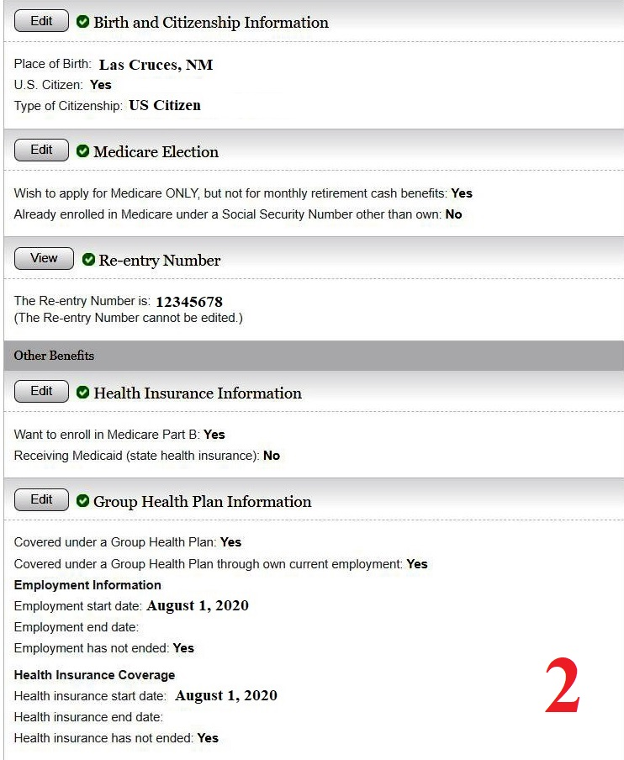

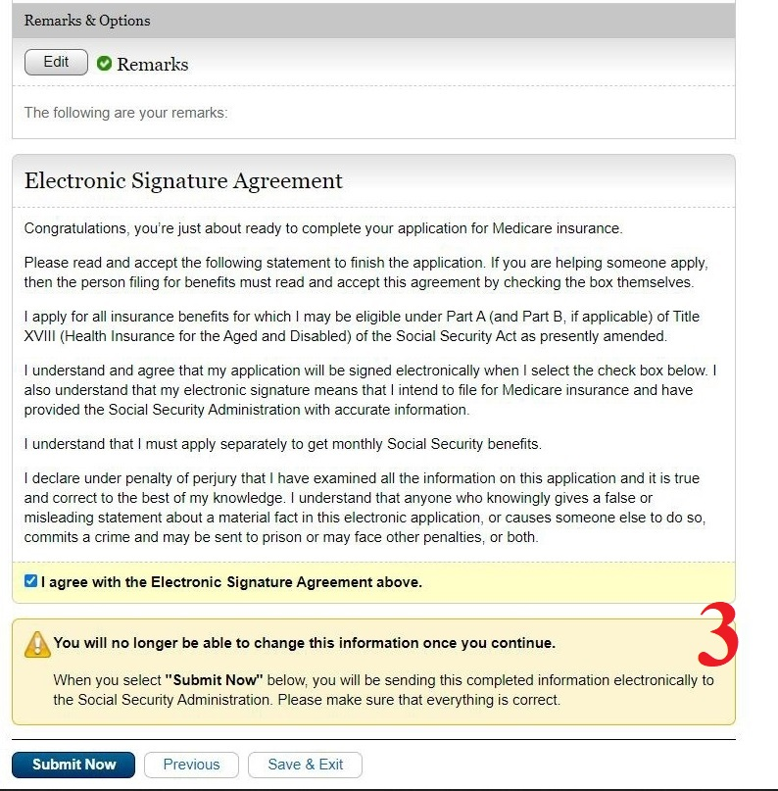

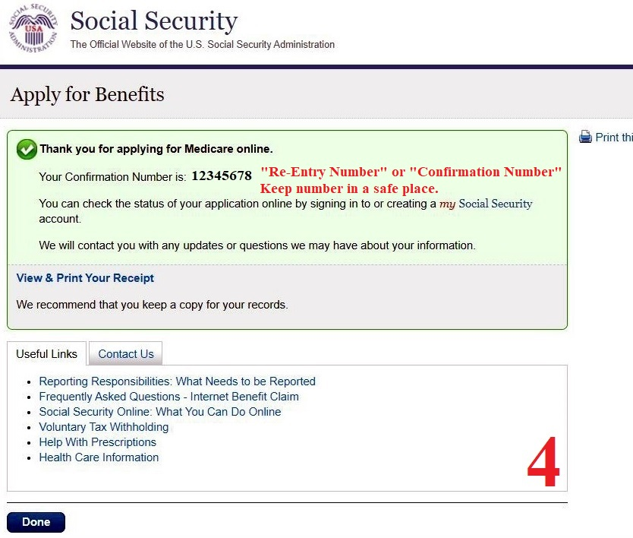

(3) When completed, you will receive an email confirming your enrollment for Medicare Part-A and (if applicable) Part-B. You will also receive a Medicare Account Number typically in a few days from enrollment.

(4) Once you have received your Medicare Account Number (and typically you will have that number within a few days via email), create a Medicare Account/Login Page.
https://www.medicare.gov/sign-up-change-plans

(A) Once an account is created, you can order a new Medicare Card, pay you Part-B bill, etc.

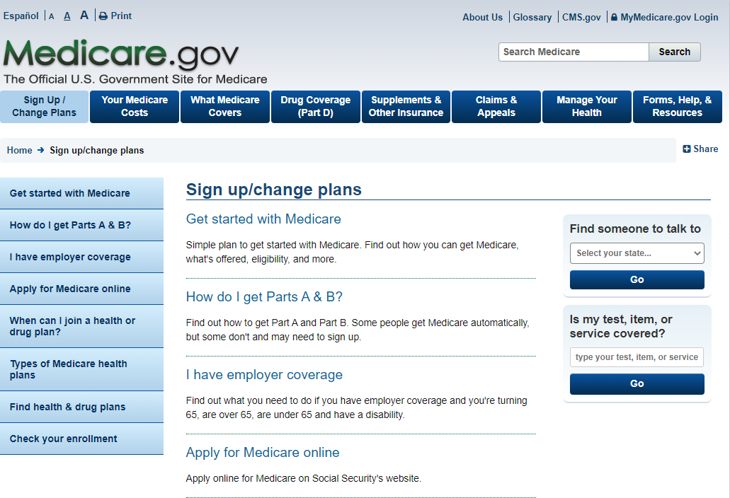

Medicare Costs:
Medicare Part-A (Hospital) is free for most people.
Medicare Part-B (Medical) for 2021 standard is: $148.50/month

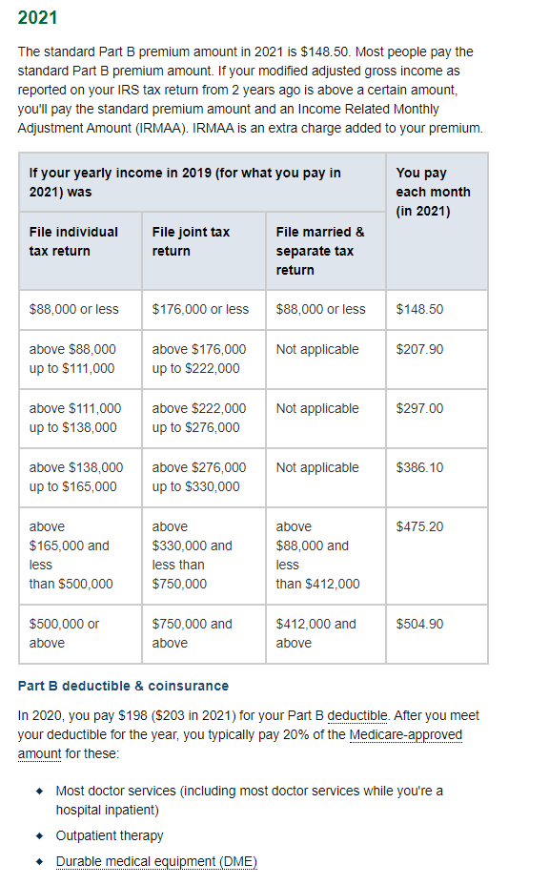

After Medicare Part-A and Part-B, you will have to decide on Medicare Supplemental Insurance, and is provided by private insurance companies (i.e., Humana, Aetna, etc).

There are 2 different plans to choose from. Go over the insurance companies that offer the plans and choose the plan that best fits your health and lifestyle.

The choices are:
(1) Medicare Advantage Plan (Part-C, and most plans include Part-D) or,
(2) Medigap.

Go to the web link below to get more information on the difference between Medicare Advantage Plan and Medigap.

https://www.investopedia.com/articles/personal-finance/071014/medigap-vs-medicare-advantage-which-better.asp

My understanding is if you are in good health, then Medicare Advantage Plan is the better choice.

